**MODULE 4 – Introduction to Policy For EV**

**4.2 Policies and Policy Instruments**

Practice Problems

### Question 1 In the list of 9 items below, 6 are pollutants described in the lecture. Please check the boxes of these 6 pollutants.

1. NOx
2. Sox
3. PMS5
4. HxO
5. H2S
6. Ammonia
7. PM10
8. PM2.5
9. Argon

Ans. A, B, E, F, G, H

### Question 2 What is the reason that many national, regional and municipal governments have been keen to curb traffic and stimulate cleaner transportation from a public health perspective?

1. The reduction in traffic allows a more efficient use of roads, reducing the cost of maintenance.
2. The reduction in traffic allows a more efficient use of roads, reducing the economic damage resulting from the traffic’s delays.
3. The reduction in traffic reduces the amount of NO2 emissions, improving the health of nearby residents.
4. None of the above.

Ans. C

Question 3 Please read [this document](https://courses.edx.org/assets/courseware/v1/fb1f549f36195765baf358ed33c623da/asset-v1:DelftX+eCARS1x+3T2019+type@asset+block/ets_handbook_en_16-17.pdf) to learn how the EU ETS system works. Now, look at the image below and read the two statements below the image.

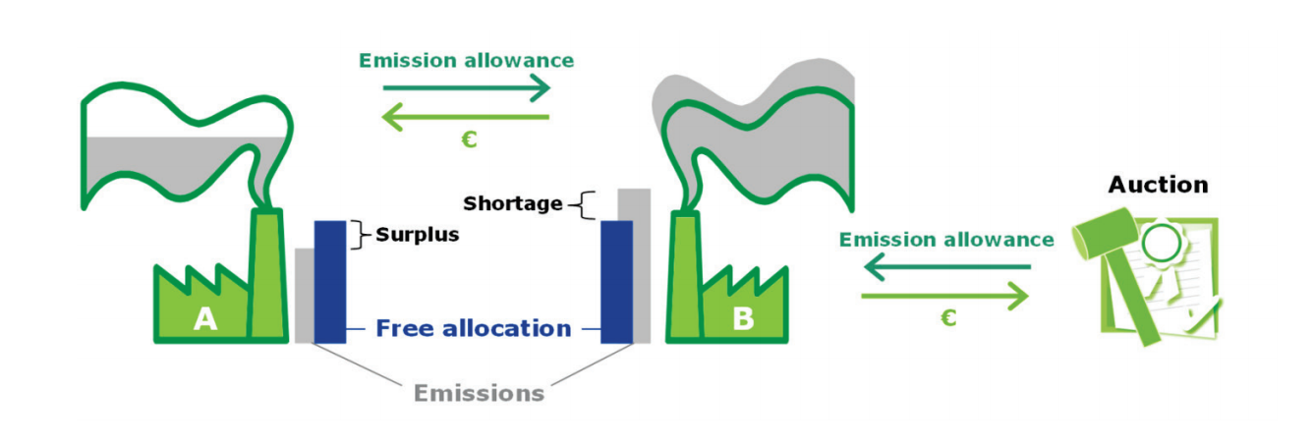

Statements:

1. In the above image, company A has a surplus of emission rights as it is polluting less than company B, which is polluting more than the allowed emissions.
2. According to the ETS, company B will have to buy more emission rights in order to pollute more. These can be sold by company A in an auction.
3. Not complying with the ETS by polluting more than the allowed emissions results in strong fines.
4. The objective of the ETS is to create a system in which the reduction of emissions become an investment and a source of future income, instead of just a burden.

Which statement(s) are correct?

1. Only statement 1 is correct
2. Both statements 1 and 2 are correct, whilst 3 and 4 are false
3. The statements 1, 2, and 3 are correct, whilst 4 is false.
4. All four statements are correct

Ans. D

### Question 4 Reading through the document on the ETS given in question 3, what is the argument for the idea that the certificates have value?

1. Participants with higher cost of emission reduction are mandated to source for more allowance from a market with limited supply. The allowances become valuable through scarcity.
2. Companies can buy emission rights now and stock them over a couple of years for a profit.
3. The emission rights which are not used are tax deductible, which is why companies try to buy the emission rights at auction for the right price.
4. None of the above.

Ans. A